Erosion

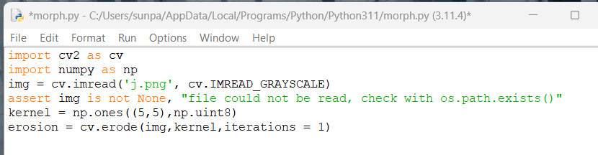

Removes 1’s in kernel touching 0’s

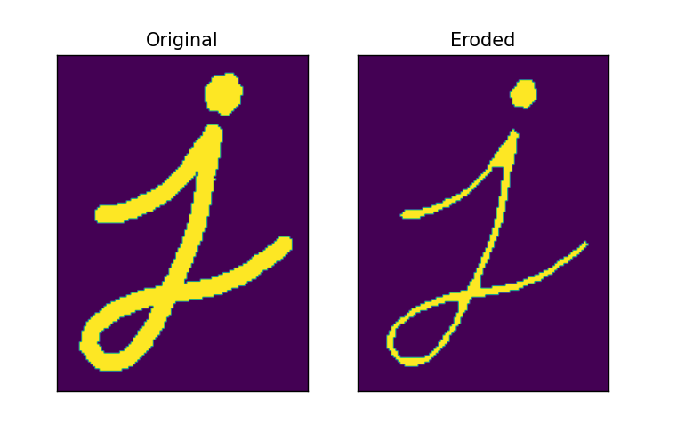

Dilation, Turns 0’s touching 1s into 1s



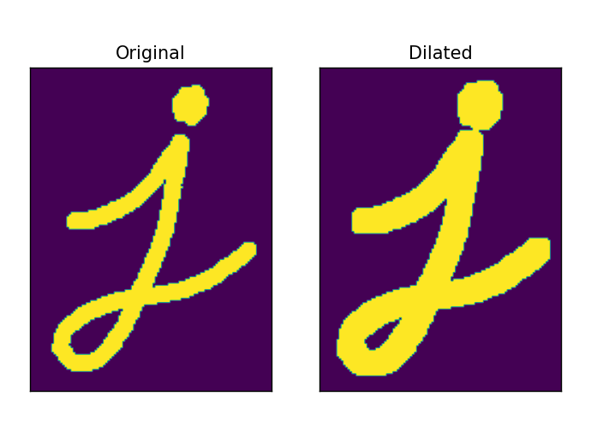

Opening (Erosion then dilation to remove noise)



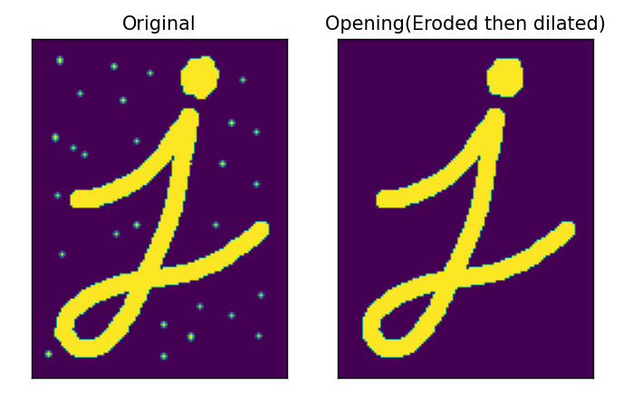

Closing (Dilation then Erosion)



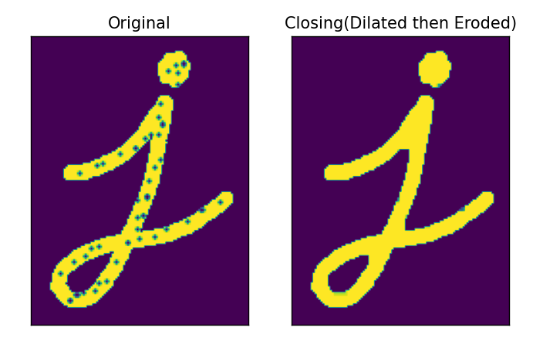

Morphological Gradient is the difference between the dilation and erosion of an image



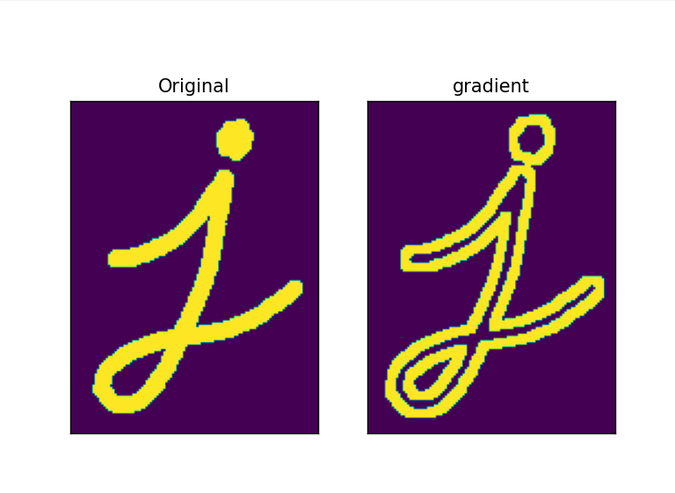

Tophat is the difference between the initial image and the opening



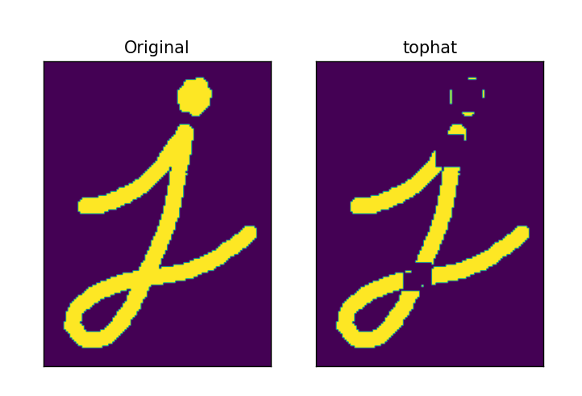

Using 9 by 9 kernel

Black hat is the difference between the closing and the initial image



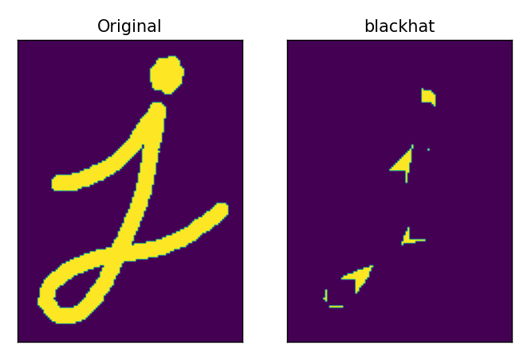

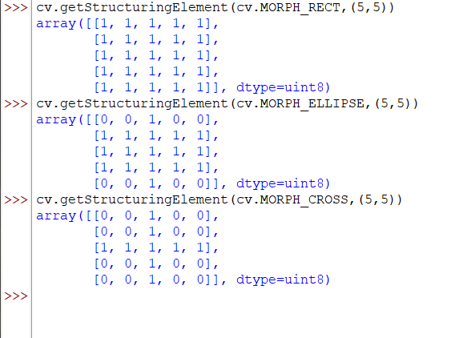

Get structuring element can make kernels for you